DAY 6 –AZURE STORAGE

Creating different storage resources as per different storage types (LRS, ZRS, GZRS, ZRS) –

LRS -

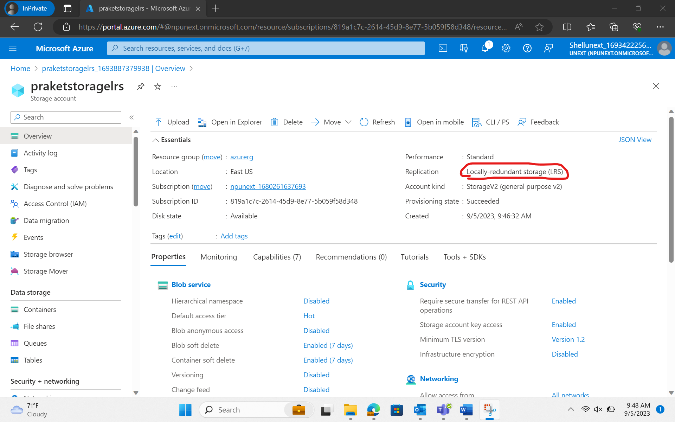

ZRS –

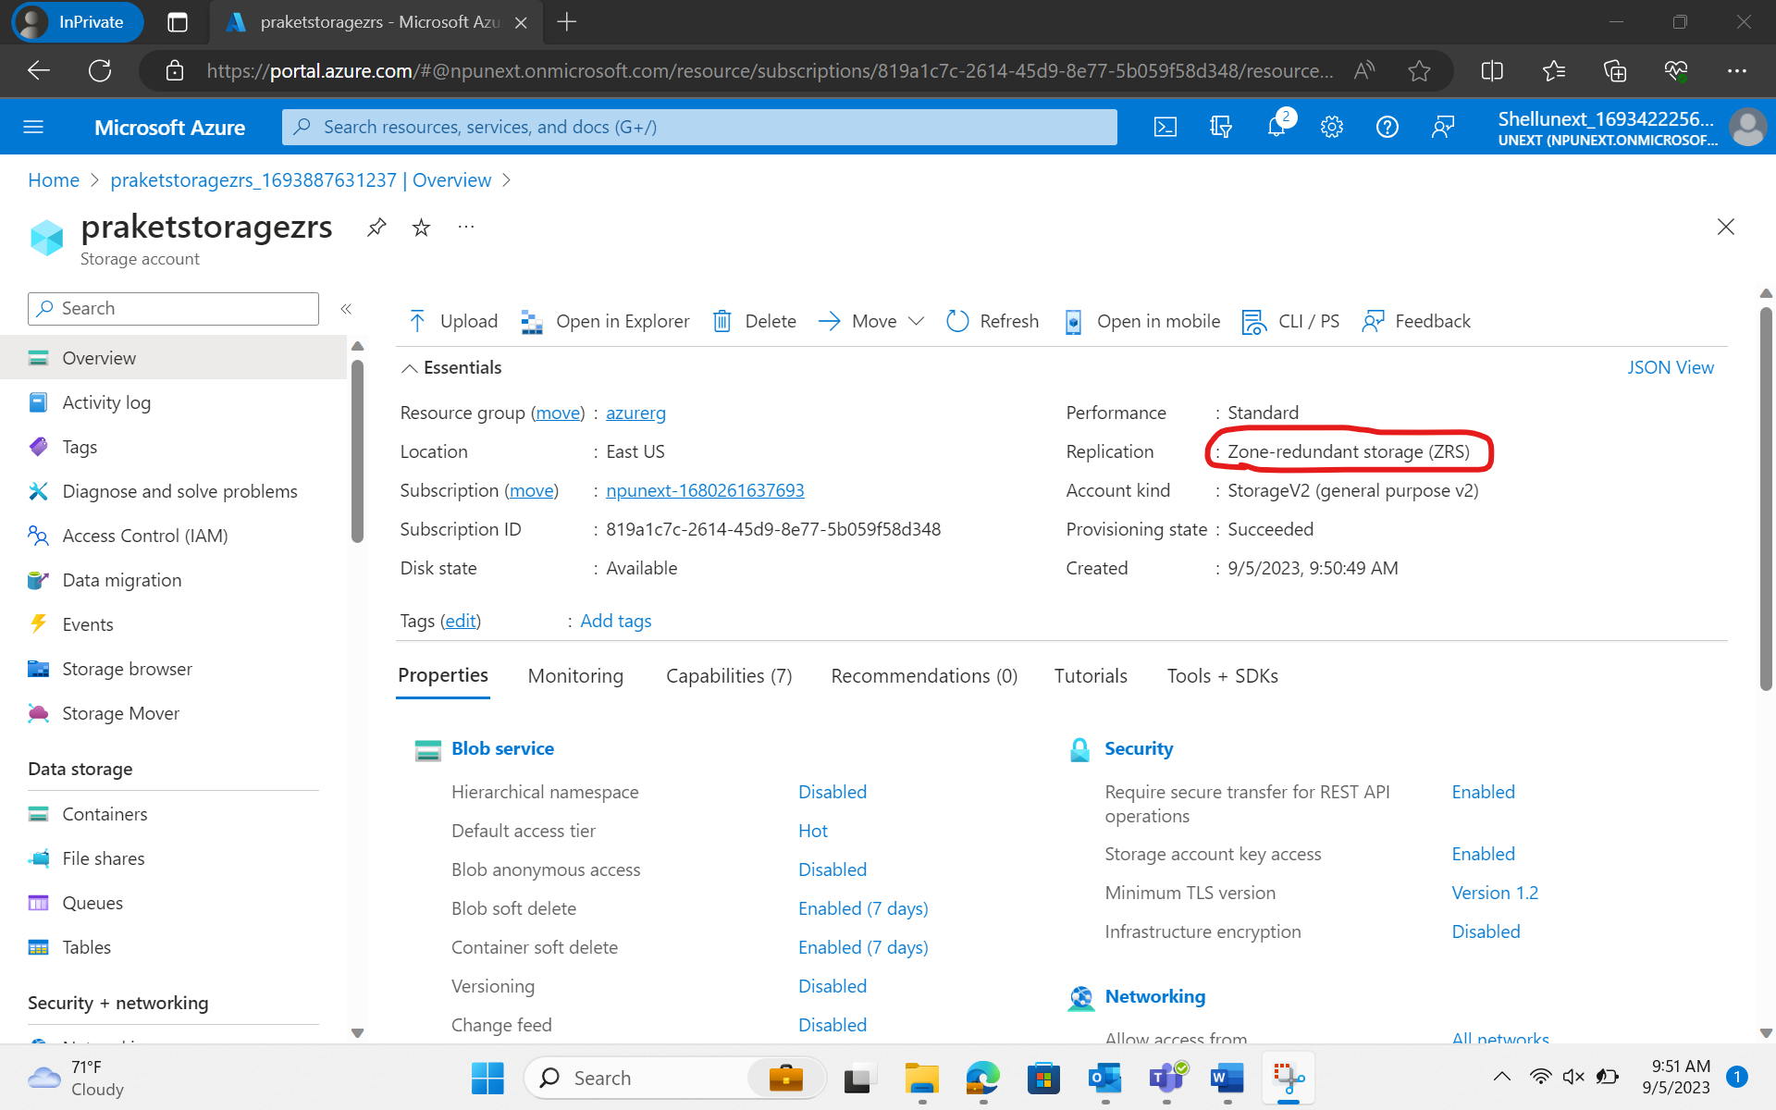

GZRS –

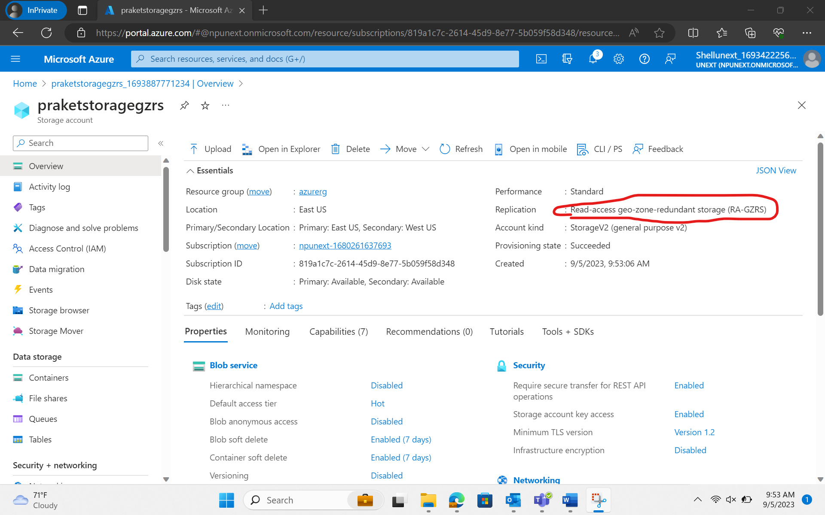

GRS –

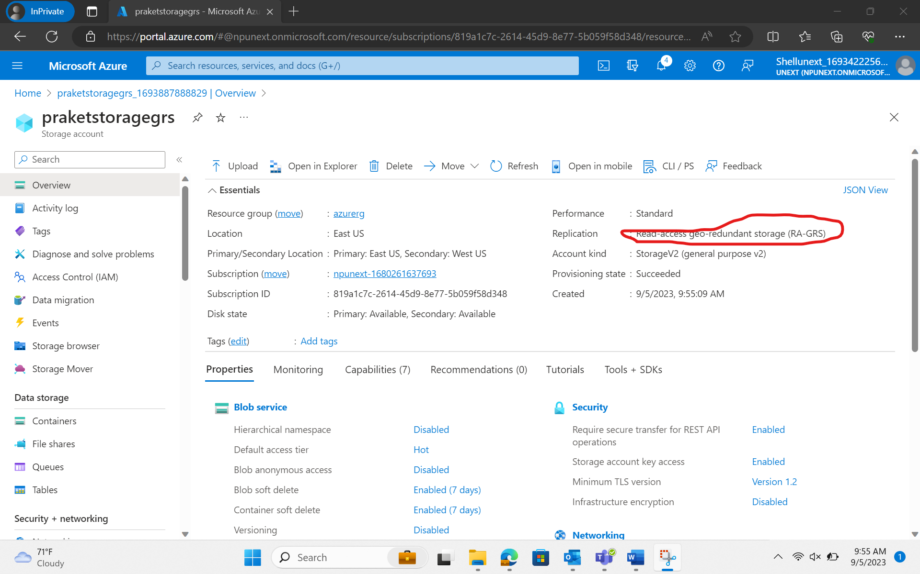

Containers –

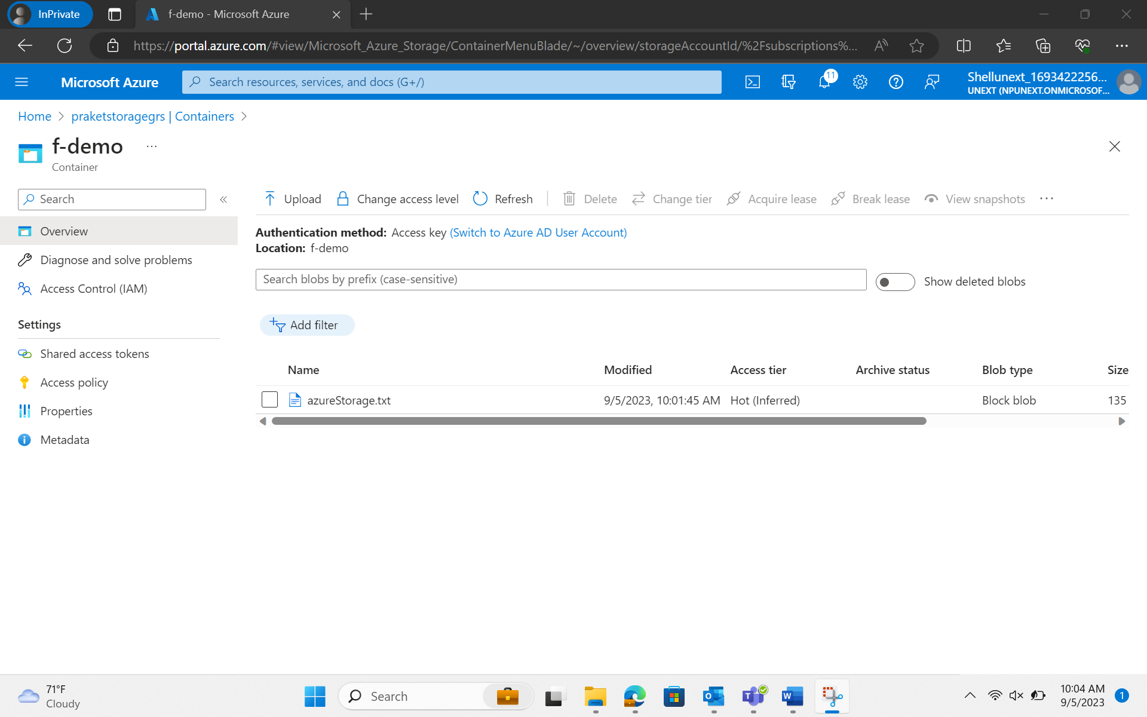

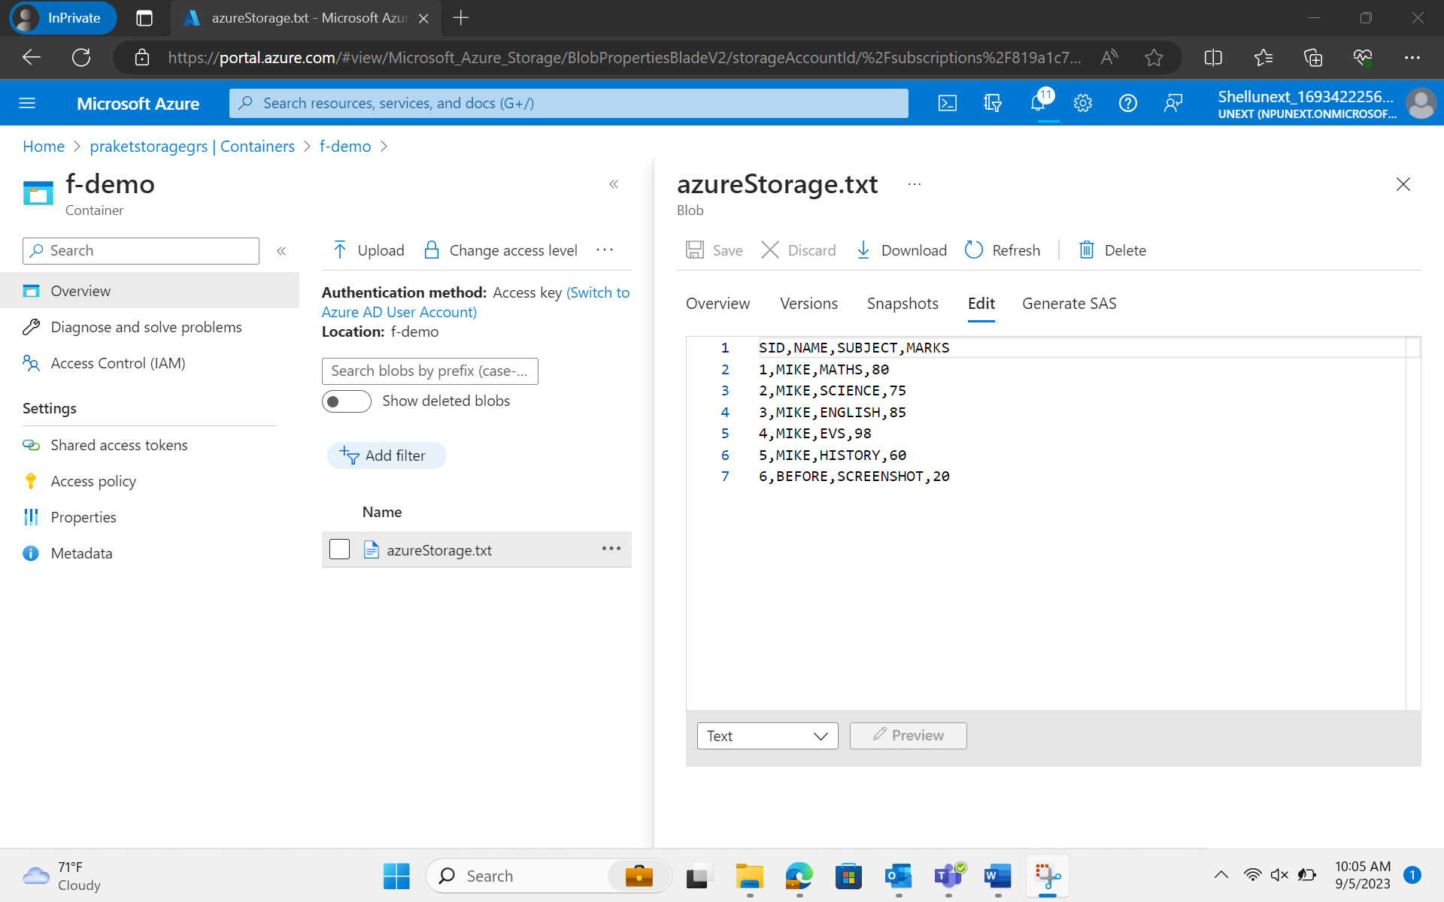

File Share –

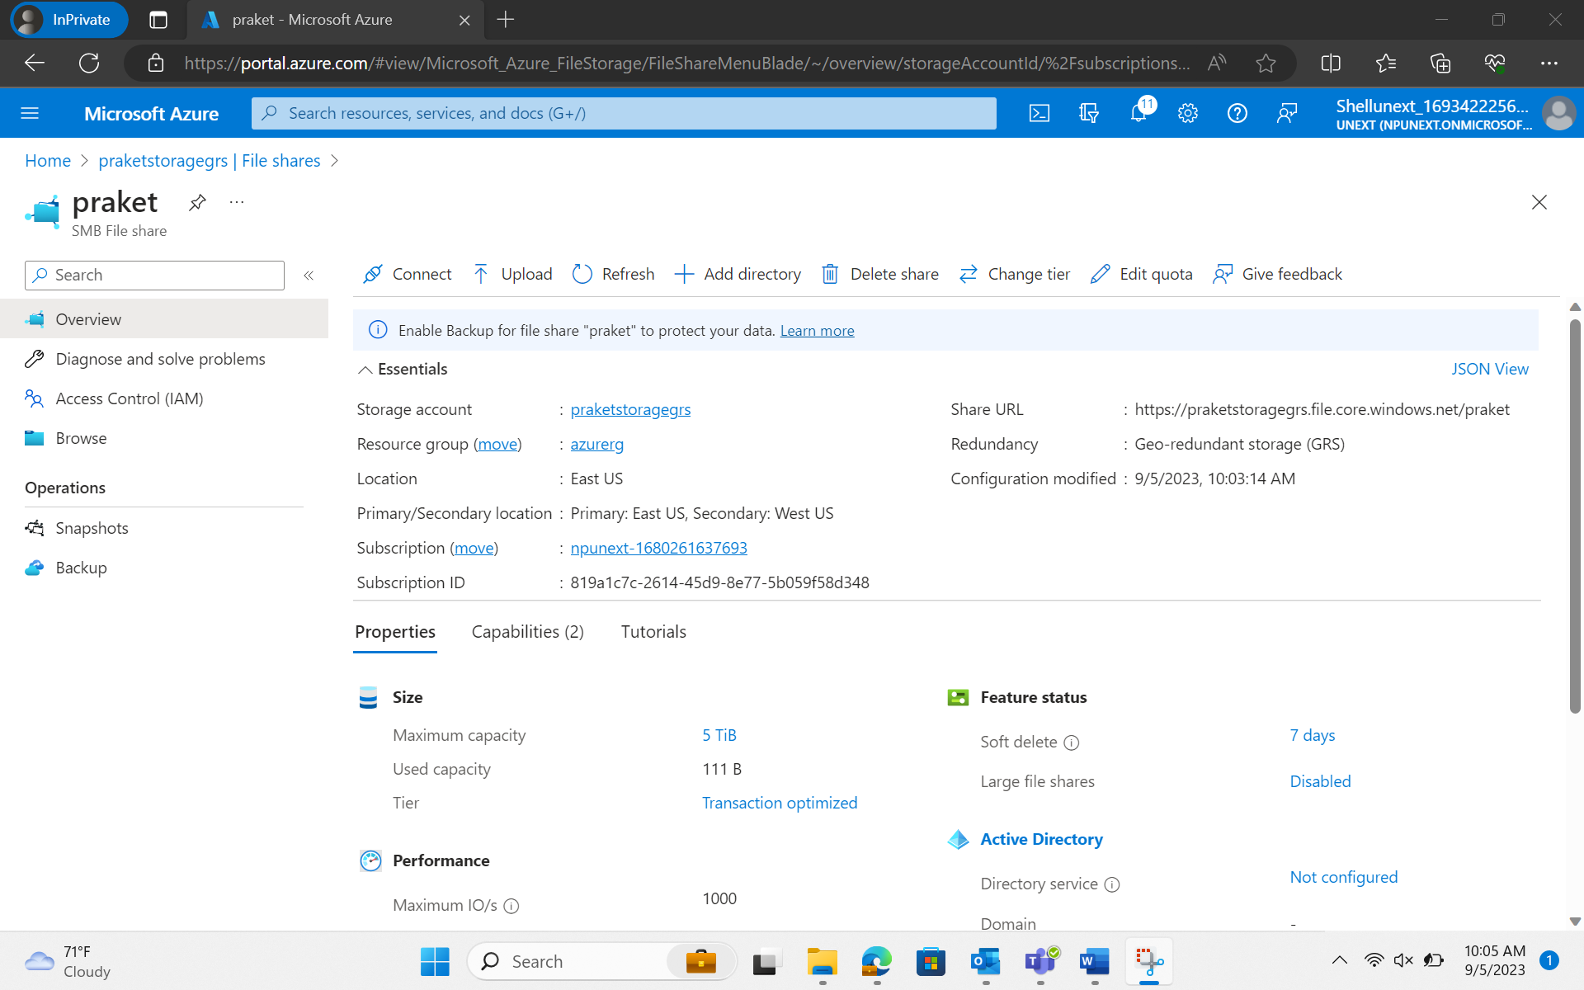

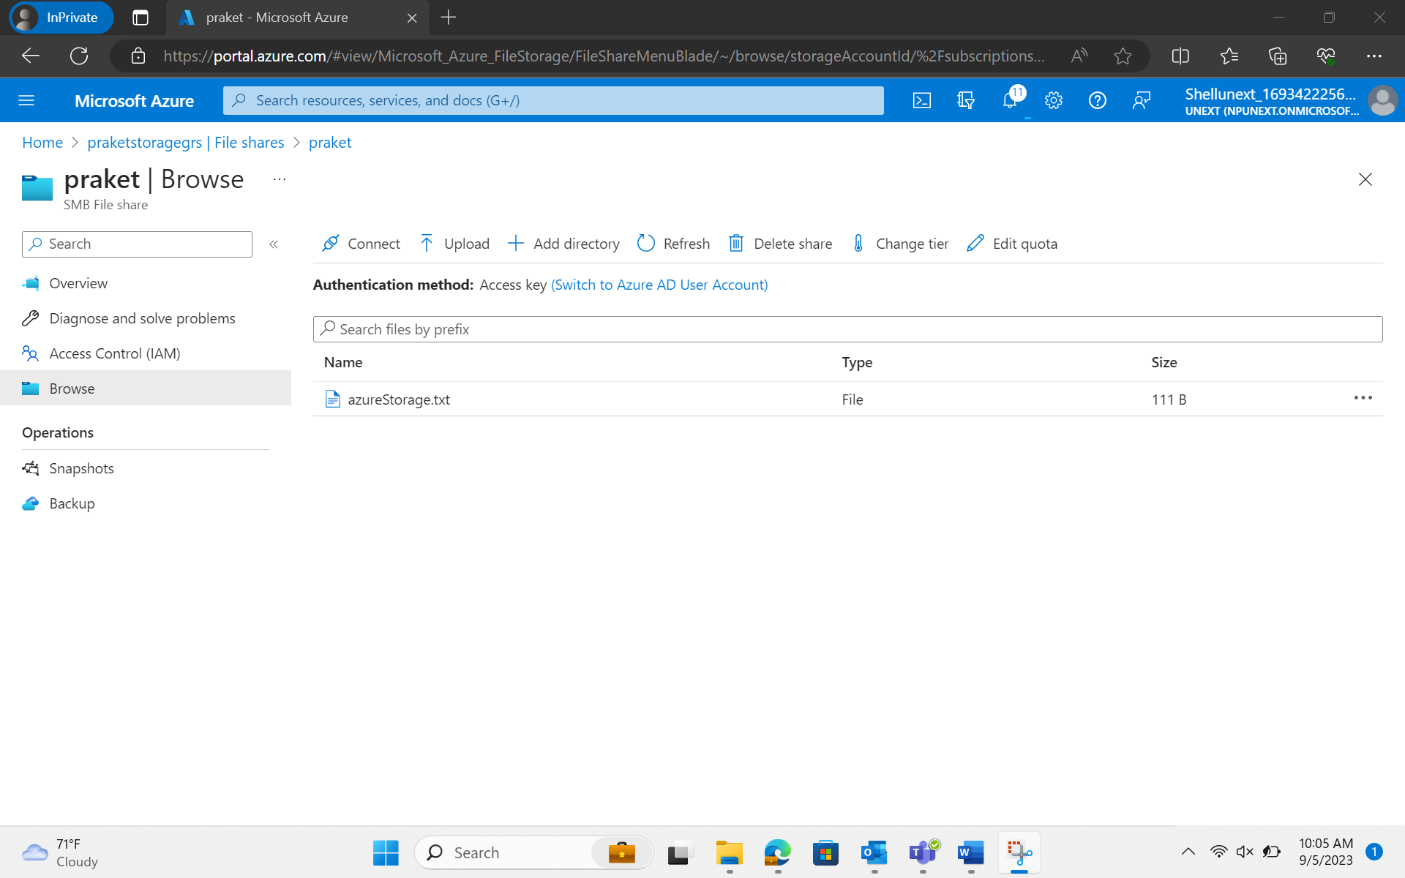

Queues –

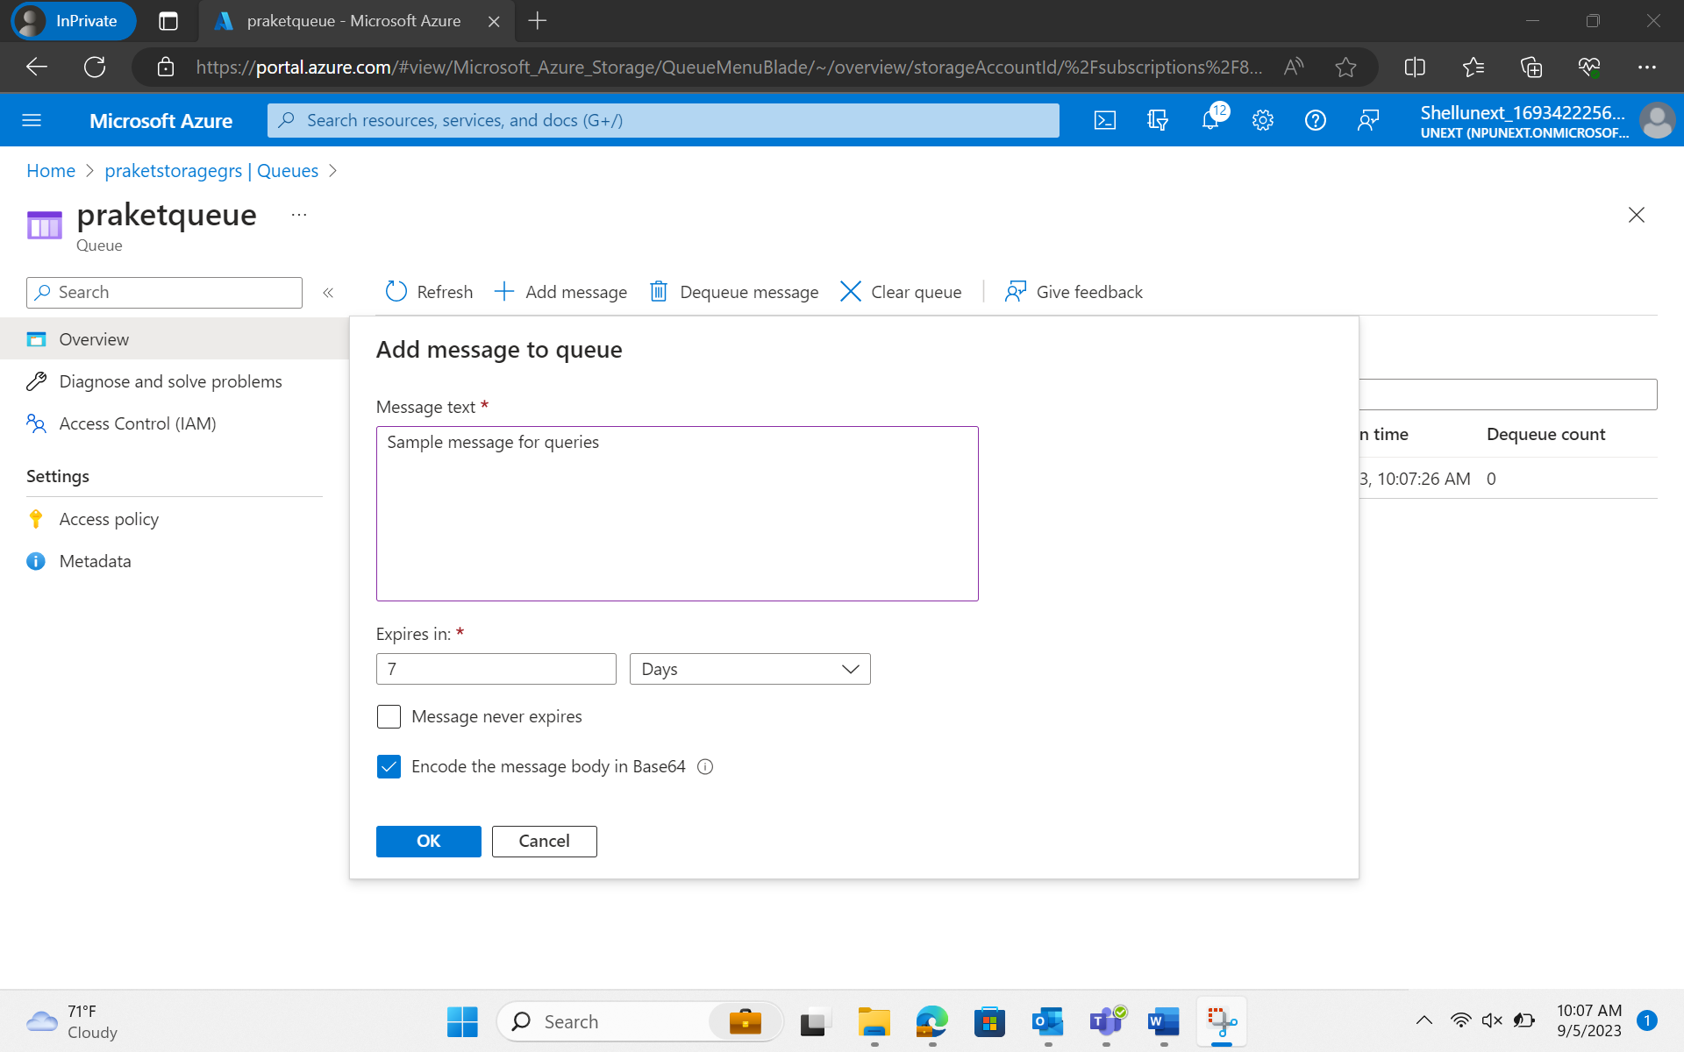

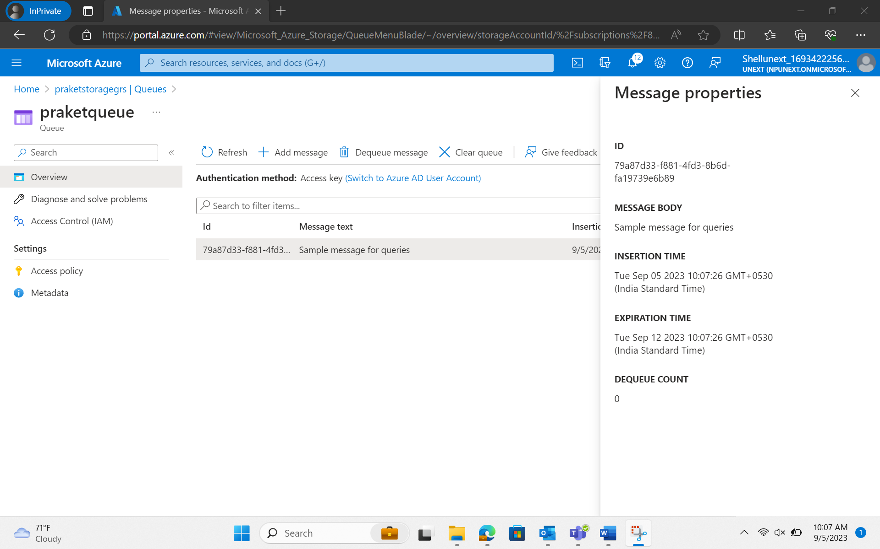

Azure active directory(Azure AD) integration for authorizing request to blob queue and table resources, Microsoft recommends using azure ad credentials to authorize request to data when possible for optimal security and ease of use.

we can use azure role based access control to manage a security principle permission to blob, queue and table resources into storage accounts.

Access Keys –

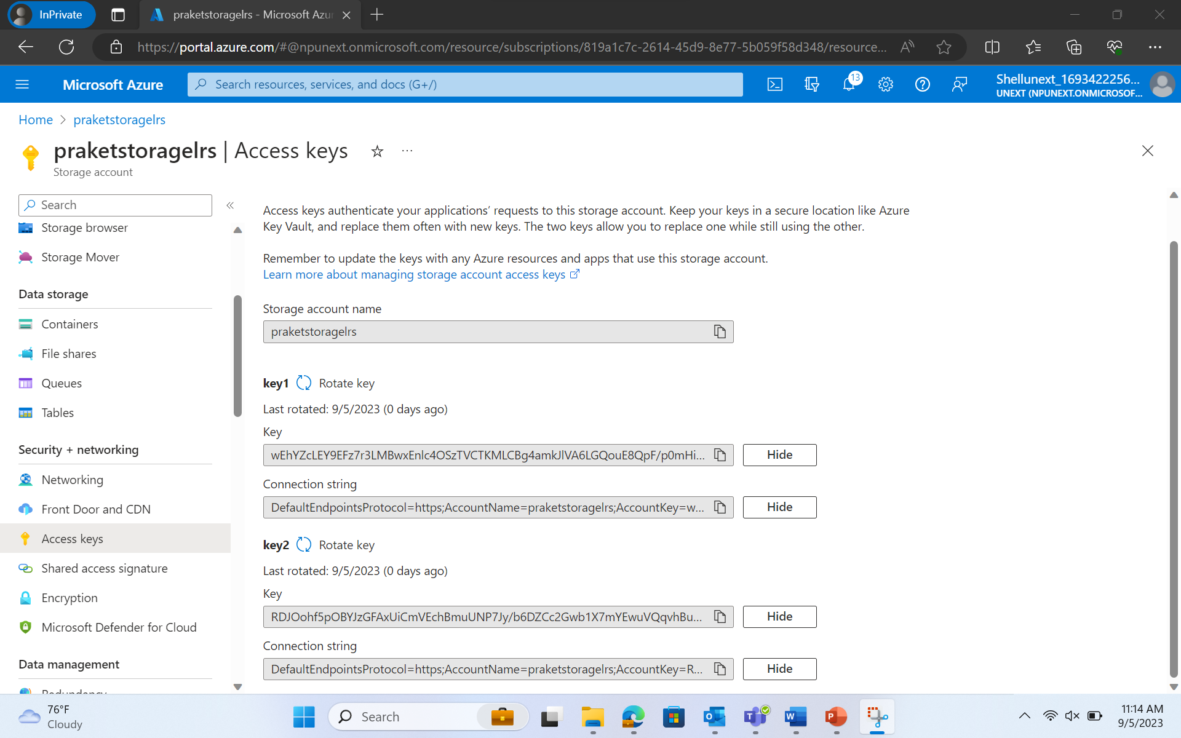

Shared Access Signatures –

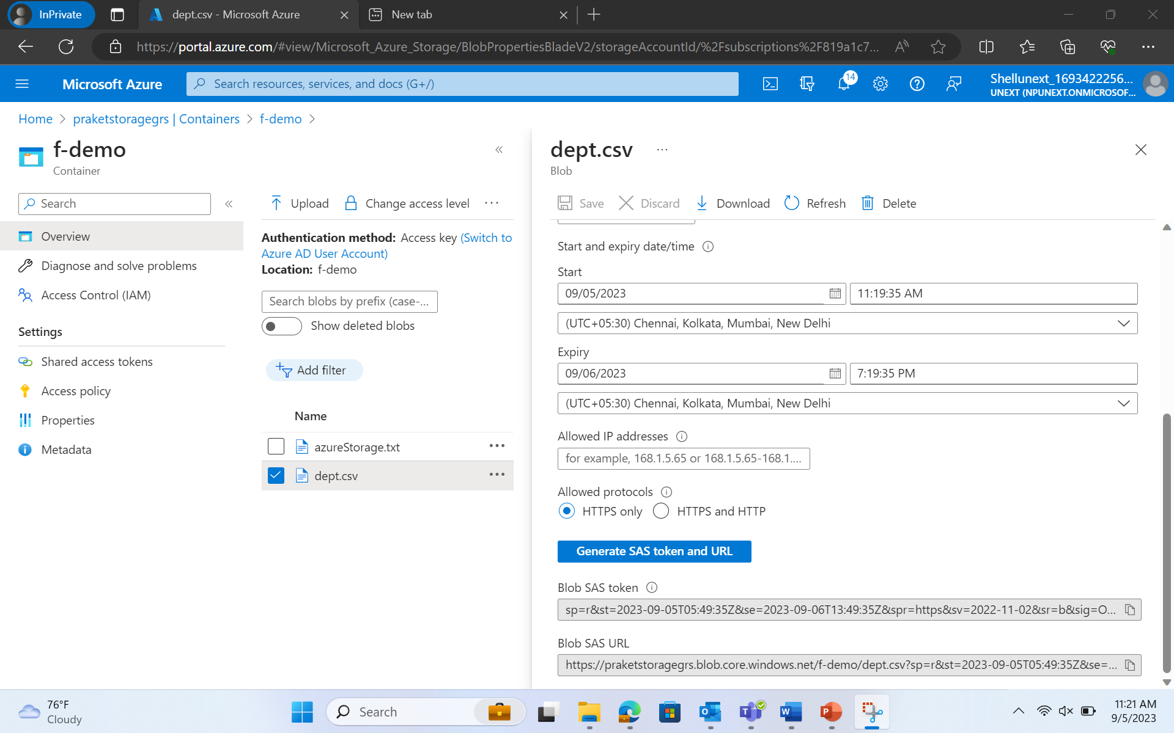

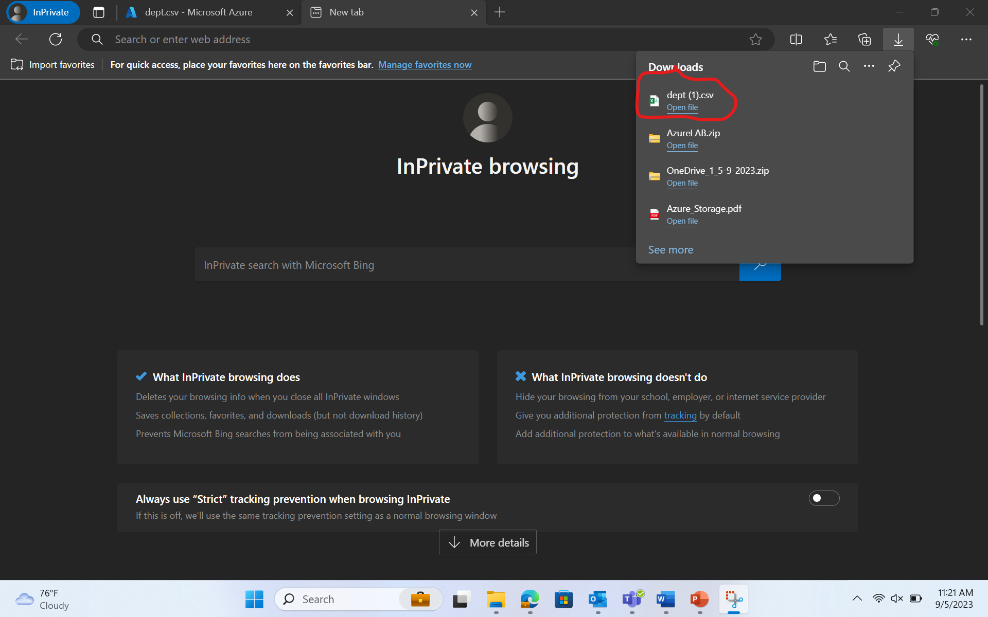

Azure Data Factory –

